PRIVACY COLLECTION STATEMENT – Primary Schools
Information for parents and carers
During the ordinary course of your child’s attendance at our school, school staff will collect your child’s personal and health information when necessary to educate your child, or to support your child’s social and emotional wellbeing or health in the school context. Such information will also be collected when required to fulfil a legal obligation, including duty of care, anti-discrimination law, occupational health and safety law, and child wellbeing and safety law. If that information is not collected, the school may be unable to provide optimal education or support to your child, or fulfil those legal obligations.
For example, health information may be collected through the school nurse, primary welfare officer or wellbeing staff member. If your child is referred to a specific health service at school, such as a Student Support Services officer, the required consent will be obtained. Our school also collects information provided by parents and carers through the School Entrance Health Questionnaire (SEHQ) and the Early Childhood Intervention Service (ECIS) Transition Form.
Our school may use online tools, such as apps and other software, to effectively collect and manage information about your child for teaching and learning purposes, parent communication and engagement; student administration; and school management purposes. When our school uses these online tools, we take steps to ensure that your child’s information is secure. If you have any concerns about the use of these online tools, please contact us.
School staff will only share your child’s personal or health information with other staff who need to know to enable the school to educate or support your child, or fulfil a legal obligation. Information will only be shared outside the Department of Education and Training as required or authorised by law, including where sharing is required in order for the Department of Education and Training to meet its duty of care, anti-discrimination, occupational health and safety, and child wellbeing and safety obligations. The information collected will not be disclosed beyond the Department of Education and Training without your consent, unless such disclosure is lawful.
When our students transfer to another Victorian government school, personal and health information about that student will be transferred to that next school. Transferring this information is in the best interests of our students and assists that next school to provide the best possible education and support to students.
In some limited circumstances, information may be disclosed outside of the school (and outside of the Department of Education and Training). The school will seek your consent for such disclosures unless the disclosure is allowed or mandated by law.
Our school values the privacy of every person. When collecting and managing personal and health information, all school staff must comply with Victorian privacy law. For more information about privacy including about how to access personal and health information held by the school about you or your child, see our school’s privacy policy: https://www.education.vic.gov.au/Pages/schoolsprivacypolicy.aspx
Throughout this notice, ‘staff’ includes principals, teachers, Student Support Service officers, youth workers, social workers, nurses and any other allied health practitioners and all other staff at our school. This also includes employees, agents and service providers (contractors) of the Department, whether paid or unpaid.

PRIVACY COLLECTION STATEMENT – Enrolment Information for Parents and Carers

The Enrolment Form asks you for personal and health information about your child and your family. This information is collected to enable our school to educate your child and support your child’s social and emotional wellbeing and health. Our school is also required by legislation, such as the Education and Training Reform Act 2006, to collect some of this information.
Our school relies on you to provide health information about any medical condition or disability that your child has, medication your child may take while at school, any known allergies and contact details of your child’s doctor. If you do not provide all relevant health information, this may put your child’s health at risk.
Our school requires current, relevant information about all parents and carers so that we can take account of family arrangements. Please provide our school with copies of all current parenting plans AND court orders regarding parenting arrangements. Please provide copies of court orders or plans when they change. If you wish to discuss any matters regarding family arrangements in confidence, please contact the principal.

Protecting your privacy and sharing information
The information about your child and family collected through this Enrolment Form will only be shared with school staff who need to know, to enable our school to educate or support your child. Information will only be shared outside the Department of Education and Training as required or authorised by law, including where sharing is required in order for the Department of Education and Training to meet its duty of care, anti-discrimination, occupational health and safety, and child wellbeing and safety obligations. The information collected will not be disclosed beyond the Department of Education and Training without your consent, unless such disclosure is lawful.
For more about information, see our school’s privacy policy: https://www.education.vic.gov.au/Pages/schoolsprivacypolicy.aspx

Our school’s use of online tools (including apps and other software) to collect and manage information
Our school may use online tools, such as apps and other software, to effectively collect and manage information about your child for teaching and learning purposes, parent communication and engagement; student administration; and school management purposes. When our school uses these online tools, we take steps to ensure that your child’s information is secure. If you have any concerns about the use of these online tools, please contact us.

Emergency contacts
Emergency contacts are those people you nominate for the school to contact during an emergency. Please ensure your nominated emergency contact agrees to you providing their contact details to our school and that they have read the paragraph above. It is important that you inform them that their contact details may be disclosed beyond the Department if lawful.

Student background information
The enrolment form requests information about country of birth, aboriginality, language spoken at home and parent occupation. This information enables the Department to allocate appropriate resources to our school. The Department also uses this information to plan for future educational needs in Victoria and shares some information with the Commonwealth government to monitor, plan and allocate resources.

Immunisation status
Your child’s immunisation status assists our school to manage health risks for children. The Department may also provide this information to the Department of Health and Human Services to assess immunisation rates in Victoria, but not in a way which identifies you.

Visa status
Our school also requires this information to process your child’s enrolment.

Updating your child’s personal and health information
Please inform our school if, and when, there are any updates to any of the personal or health information you provide on the Enrolment Form.

Accessing your child’s records
Our school provides ordinary school communications and school reports to students and parents and carers who have legal decision-making responsibility for the student. Requests for any other type of student records may be made through a Freedom of Information (FOI) application. Please contact our school and we can advise you how to do this.

Student transfers between Victorian government schools
When our students transfer to another Victorian government school, our school will transfer the student’s personal and health information to that next school. This may include copies of student’s school records, including any health information. Transferring this information assists the next school to provide the best possible education and support to students.

Mahogany Rise Primary School

STUDENT ENROLMENT INFORMATION – 20__ | Computer Generated Student ID:

Student Details

Personal Details of Student
Surname: |  |  |  |  | Title: (Miss Ms, Mrs, Mx, Mr)

First Given Name:

Second Given Name:
Preferred Name (if applicable): |  |  |  |  |  | Birth Date: (dd-mm-yyyy) |  | ___ / ___ / ___
Gender | Male Female |  |  | _______________________________________________ (fill in blank)

Primary Family Home Address:

No. & Street: or PO Box details

Suburb:
State: |  | Postcode:
Telephone Number: |  | Silent Number: (tick) | Yes | No
Mobile Number: |  | Fax Number:

OFFICE USE ONLY
Child’s Name and Birth Date proof sighted (tick) |  |  |  |  | Yes |  | No |  |  | Enrolment Date:
Year Level |  | Home Group |  | Timetabling Group |  |  |  | House |  |  |  | Campus
Student Email Address:
Immunisation Certificate received?: (tick) |  |  |  |  | Complete |  |  |  | Not sighted
Is there a Medical Alert for the student? (tick) |  |  |  |  | Yes |  | No
Does the student have a Disability ID Number? (tick) |  |  |  |  | No |  | Yes |  |  | Disability ID No.:
Has a Transition Statement been provided (either by the Early Childhood Educator or parents)? (tick)  For prep students only |  |  |  |  | Yes |  | No |  |  | Pending

Family Details

List any other family members attending this school:
Does the student have any younger siblings? (If so please write child’s name and date of birth)
This question is asked as a requirement of the Commonwealth Government. All schools across Australia are required to collect the same information.

Primary Family Details
NOTE: The ‘PRIMARY’ Family is: “the family or parent the student mostly lives with”. If you are a separated family and the student lives between houses, please ALSO fill the Alternative Family Details on pages 5 - 7

Adult A Details (Primary Carer):

Gender : | Male |  | Female ___________ fill in blank
Title: (Ms, Mrs, Mr, Mx, Dr etc)

Legal Surname:

Legal First Name:
What is Adult A’s occupation?
Who is Adult A’s employer?

In which country was Adult A born?
Australia | Other (please specify):
Does Adult A speak a language other than English at home? (If more than one language is spoken at home, indicate the one that is spoken most often.) (tick)
- No, English only
- Yes (please specify):
Please indicate any additional languages spoken by Adult A:
Is an interpreter required? (tick) |  |  |  |  | Yes |  | No
What is the highest year of primary or secondary school Adult A has completed? (tick one) (For persons who have never attended school, mark ‘Year 9 or equivalent or below’.)
Year 12 or equivalent
Year 11 or equivalent
Year 10 or equivalent
Year 9 or equivalent or below
What is the level of the highest qualification the Adult A has completed? (tick one)
Bachelor degree or above
Advanced diploma / Diploma
Certificate I to IV (including trade certificate)
No non-school qualification
What is the occupation group of Adult A? Please select the appropriate parental occupation group from the attached list.
- If the person is not currently in paid work but has had a job in the last 12 months, or has retired in the last 12 months, please use their last occupation to select from the attached occupation group list.
- If the person has not been in paid work for the last 12 months, enter ‘N’.

Adult B Details:

Gender: | Male |  | Female ___________ fill in blank
Title: (Ms, Mrs, Mr, Mx, Dr etc)

Legal Surname:

Legal First Name:
What is Adult B’s occupation?
Who is Adult B’s employer?

In which country was Adult B born?
Australia | Other (please specify):
Does Adult B speak a language other than English at home? (If more than one language is spoken at home, indicate the one that is spoken most often.) (tick)
- No, English only
- Yes (please specify):
Please indicate any additional languages spoken by Adult B:
Is an interpreter required? (tick) |  |  |  |  | Yes |  | No
What is the highest year of primary or secondary school Adult B has completed? (tick one) (For persons who have never attended school, mark ‘Year 9 or equivalent or below’.)
Year 12 or equivalent
Year 11 or equivalent
Year 10 or equivalent
Year 9 or equivalent or below
What is the level of the highest qualification the Adult B has completed? (tick one)
Bachelor degree or above
Advanced diploma / Diploma
Certificate I to IV (including trade certificate)
No non-school qualification
What is the occupation group of Adult B? Please select the appropriate parental occupation group from the attached list.
- If the person is not currently in paid work but has had a job in the last 12 months, or has retired in the last 12 months, please use their last occupation to select from the attached occupation group list.
- If the person has not been in paid work for the last 12 months, enter ‘N’.

These questions are asked as a requirement of the Commonwealth Government. All schools across Australia are required to collect the same information

Main language spoken at home: |  | Preferred language of notices:
Are you interested in being involved in school group participation activities? (eg. School Council, excursions) (tick) |  | Adult A | Adult B | Both |  | Neither

Primary Family Contact Details

Adult A Contact Details:

Business Hours:
Can we contact Adult A at work? (tick) |  | Yes | No
Is Adult A usually home during business hours? (tick) |  | Yes | No

Work Telephone No:

Other Work Contact information:

After Hours:
Is Adult A usually home AFTER business hours? (tick) |  |  |  |  |  | Yes |  |  | No

Home Telephone No:

Other After Hours Contact Information:
Mobile No:
SMS Notifications: |  |  |  |  | Yes |  |  | No
Adult A’s preferred method of contact: (tick one)
(If Phone is selected, Email shall be used for communication that cannot be sent via phone.)
Mail | Email |  |  | Phone |  |  | Facsimile

Email address:
Email Notifications: |  |  |  |  | Yes |  |  | No

Fax Number:

Adult B Contact Details:

Business Hours:
Can we contact Adult B at work? (tick) |  | Yes | No
Is Adult B usually home during business hours? (tick) |  | Yes | No

Work Telephone No:

Other Work Contact information:

After Hours:
Is Adult B usually home AFTER business hours? (tick) |  |  |  |  |  | Yes |  | No

Home Telephone No:

Other After Hours Contact Information:
Mobile No:
SMS Notifications: |  |  |  |  |  | Yes |  |  |  | No
Adult B’s preferred method of contact: (tick one)
(If Phone is selected, Email shall be used for communication that cannot be sent via phone.)
Mail | Email |  |  | Phone |  |  | Facsimile

Email address:
Email Notifications: |  |  |  |  | Yes |  |  |  | No

Fax Number:

Primary Family Doctor Details:
Doctor’s Name |  |  |  |  |  | Individual or Group Practice: (tick) |  |  |  | Individual | Group

No. & Street or PO Box No.:

Suburb:
State: |  |  |  |  |  |  |  | Postcode:
Telephone Number |  |  |  |  |  |  |  | Fax Number
Current Ambulance Subscription: (tick) |  |  |  | Yes | No |  | Heathcare Card Number:
Medicare Number: |  |  |  |  |  |  | Expiry date: ____ / ______ |  |  | Ref number:

Primary Family Emergency Contacts:
*Please note: Primary family contacts cannot be the child’s parents. We recommend emergency contacts are 18 years and older, have transportation and do not live more than 30 minutes away.
 | Name | Relationship | Telephone Contact | Language Spoken
 |  | (Neighbour, Relative, Friend or Other) |  | (If English Write “E”)
1
2
3
4

Other Primary Family Details

Relationship of Adult A to Student: (tick one) | Parent | Step-Parent | Adoptive Parent
 | Foster Parent | Host Family | Relative
 | Friend | Self | Other
Relationship of Adult B to Student: (tick one) | Parent | Step-Parent | Adoptive Parent
 | Foster Parent | Host Family | Relative
 | Friend | Self | Other

The student lives with the Primary Family: (tick one)
Always | Mostly | Balanced | Occasionally | Never

These questions are asked as a requirement of the Commonwealth Government. All schools across Australia are required to collect the same information

Main language spoken at home: |  | Preferred language of notices:
Are you interested in being involved in school group participation activities? (eg. School Council, excursions) (tick) |  | Adult A | Adult B | Both |  | Neither

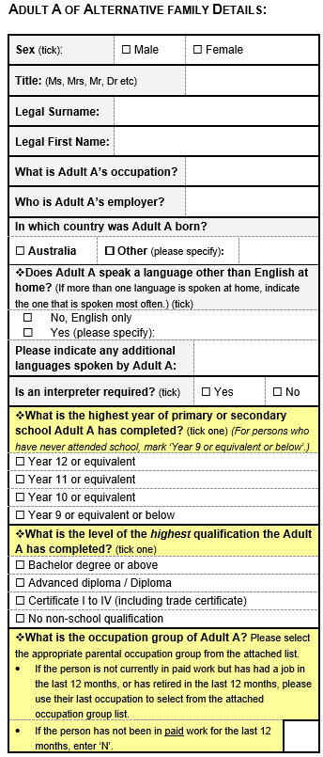
*Alternative Family Details
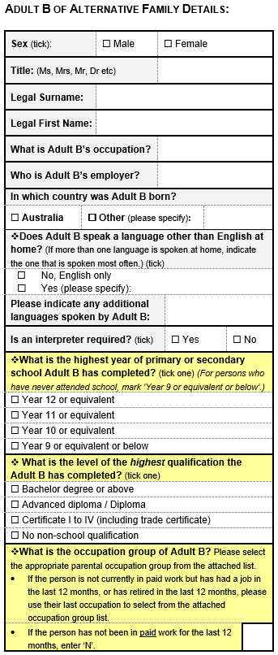
These questions are asked as a requirement of the Commonwealth Government. All schools across Australia are required to collect the same information

Main language spoken at home: |  | Preferred language of notices:
Are you interested in being involved in school group participation activities? (eg. School Council, excursions) (tick) |  | Adult A | Adult B | Both |  | Neither

Alternative Family Contact Details
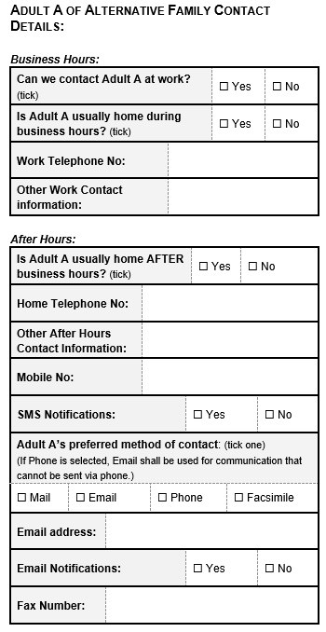
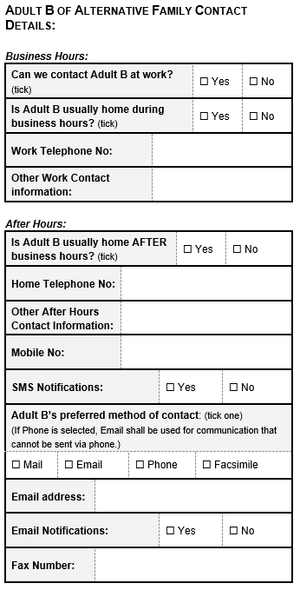

Alternative Family Home Address:

No. & Street: or PO Box details

Suburb:
State: |  | Postcode:
Telephone Number: |  | Silent Number: (tick) | Yes | No
Mobile Number: |  | Fax Number:

Other Alternative Family Details

Relationship of Adult A of Alternative Family to Student: (tick one) | Parent | Step-Parent | Adoptive Parent
 | Foster Parent | Host Family | Relative
 | Friend | Self | Other
Relationship of Adult B of Alternative Family to Student: (tick one) | Parent | Step-Parent | Adoptive Parent
 | Foster Parent | Host Family | Relative
 | Friend | Self | Other

The student lives with the Alternative Family: (tick one)
Always | Mostly | Balanced | Occasionally | Never

Send Correspondence addressed to: (tick one) | Adult A | Adult B | Both Adults | Neither
Is the Alternative Family to receive Academic Reports? | Yes |  | No

*END OF ALTERNATIVE FAMILY DETAILS SECTION

Demographic Details of Student

In which country was the student born?
Australia |  | Other (please specify): |  |  |  |  | ______________________________________
Date of arrival in Australia OR Date of return to Australia: (dd-mm-yyyy) |  |  |  |  |  |  |  | _____ / _____ / _____
What is the Residential Status of the student? (tick) |  |  |  |  |  |  | Permanent |  | Temporary

Basis of Australian Residency:
Eligible for Australian Passport |  |  |  |  | Holds Australian Passport
Holds Permanent Residency Visa
Visa Sub Class: |  |  |  | Visa Expiry Date: (dd-mm-yyyy) |  |  |  |  |  | _____ / _____ / _____
Visa Statistical Code: (Required for some sub-classes)
International Student ID :(Not required for exchange students)
Does the student speak a language other than English at home? (tick)
( If more than one language is spoken at home, indicate the one that is spoken most often)
No, English only |  |  | Yes (please specify):
Does the student speak English? (tick) |  |  |  |  |  |  |  |  |  |  | Yes | No

Is the student of Aboriginal or Torres Strait Islander origin? (tick one)
No |  |  |  |  | Yes, Aboriginal
Yes, Torres Strait Islander |  |  |  |  | Yes, Both Aboriginal & Torres Strait Islander

Is the student a young carer (providing support/care for other family member/s)? (tick one)
No |  |  |  |  | Yes
What is the student’s living arrangements? (tick one):
At home with TWO Parents/ Guardians |  |  |  |  | State Arranged Out of Home Care # (See Note)
At home with ONE Parent/ Guardian |  |  |  |  | Homeless Youth
Shared between Parents |  |  |  |  | Independent
# State Arranged Out of Home Care - Students who have been subject to protective intervention by the Department of Health and Human Services and live in alternative care arrangements away from their parents. These DHHS-facilitated care arrangements include living with relatives or friends (kith and kin), living with non-relative families (foster families or adolescent community placements) and living in residential care units with rostered care staff.

Beginning of journey to school: |  |  | Map Type |  |  |  |  | Melway / VicRoads / Country Fire Authority / Other
Map Number |  |  |  |  | X Reference |  |  |  |  |  | Y Reference
Usual mode of transport to school: (tick)
Walking |  | School Bus |  |  |  | Train |  |  |  | Driven |  | Taxi
Bicycle |  | Public Bus |  |  |  | Tram |  |  |  | Self Driven |  | Other
If student drives themself to school: |  |  |  | Car Reg. No. |  |  |  |  |  | Distance to School in kilometres:

These questions are asked as a requirement of the Commonwealth Government. All schools across Australia are required to collect the same information.

School Details

Date of first enrolment in an Australian School: |  |  |  | _____ / _____ / ______

Name of previous School or Kinder:
Years of previous education: |  |  |  | What was the language of the student’s previous education?
Does the student have a Victorian Student Number (VSN)?
- Yes.  Please specify: |  |  | - Yes, but the VSN is unknown |  |  |  |  | No. The student has never been issued a VSN.
Years of interruption to education: |  |  |  |  | Is the student repeating a year? (tick) |  |  | Yes |  |  |  | No
Will the student be attending this school full time? (tick) |  |  |  |  |  |  |  | Yes |  |  |  | No
If No, what will be the time fraction that the student will be attending this school? (i.e: 0.8 = 4 days/week)
Other school Name: |  |  |  |  |  | Time fraction: | 0. |  |  | Enrolled: | Yes |  | No
Other school Name: |  |  |  |  |  | Time fraction: | 0. |  |  | Enrolled: | Yes |  | No

Conditional Enrolment Details
In some circumstances a child may be enrolled conditionally, particularly if the required enrolment documentation to determine the shared parental responsibility arrangements for a child is not provided. Please refer to the School Policy & Advisory Library for more information https://www2.education.vic.gov.au/pal/enrolment/policy

Enrolment conditions

OFFICE USE ONLY
Has the documentation been provided and retained on school records? | Yes | No
Have the conditions been met to complete the enrolment? | Yes | No

WALKING EXCURSION PERMISSION AUTHORITY
I give permission for my child to attend excursions organised by Mahogany Rise Primary School. I understand that this authorisation covers only excursion that are within walking distance of the school grounds, do not involve any type of transport and do not involve adventure type activities such as swimming. All walking excursion will take place only after approval is granted by the Principal of the school and parents will be notified prior to the activity taking place.
I authorise the teacher-in-charge of the excursion to consent, where it is impracticable to communicate with me, to my child receiving such medical or surgical treatment as may be deemed necessary.

Signature of Parent/Guardian: Date: _____ / _____ / ______

Student Access or Activity Restrictions Details

Is the student at risk? |  | Yes |  | No
Is there an Access Alert for the student? (tick) |  | Yes (If Yes, then complete the following questions and present a current copy of the document to the school.) |  | No (If No, move to the immunisation / medical condition details questions.)
Access Type: (tick) | Parenting Order | Parenting Plan | Intervention Order |  | Protection Order
 | Informal Carer Stat Dec | DHHS Authorisation | Witness Protection Program Order |  | Other

Describe any Access Restriction:
Is there an Activity Alert for the student? (tick) |  | Yes |  | No
If Yes, then describe the Activity Restriction:

OFFICE USE ONLY
Current custody document placed on student file? | Yes | No

SCHOOL MEDIA RELEASE PERMISSION

I hereby give permission for my child to participate in any appropriate school media activities for the duration of their schooling at Mahogany Rise Primary School.
This permission includes the right to be photographed or videoed in a school activity by the school, press or television networks. They could be published in any, or, all of the following: School newsletter, on the school’s web site, school facebook page, school advertising, brochures, flickr, YouTube, newspapers or newspaper related web sites including the DET website.

I understand and agree that if I wish to withdraw this authorisation, it will be my responsibility to inform the school on 9786 3211.

Signature of Parent/Guardian: _________________________________________ Date: _____ / _____ / ______

ACCIDENT DECLARATION

In the event of illness or injury to my child whilst at school, on an excursion, or travelling to or from school; I authorise the Principal, First Aid Officer or teacher-in-charge of my child, where the Principal, First Aid Officer or teacher-in-charge is unable to contact me, or it is otherwise impracticable to contact me to:

- consent to my child receiving such medical or surgical attention as may be deemed necessary by a medical practitioner,
- administer such first aid as the Principal, First Aid Officer or staff member may judge to be reasonably necessary.

Signature of Parent/Guardian: Date: _____ / _____ / ______

HEAD LICE CONSENT FORM
I consent to my child’s hair being checked for head lice by authorised staff at Mahogany Rise Primary School.

Signature of Parent/Guardian: Date: _____ / _____ / ______

Student Medical Details

Medical Condition Details:
Does the student suffer from any of the following impairments? (tick) | Hearing: | Yes | No | Vision |  | Yes | No
 | Speech: | Yes | No | Mobility: |  | Yes | No
Does the student suffer from Asthma? (tick) If No, please go to the Other Medical Conditions section |  |  |  |  | Yes |  | No

Asthma Medical Condition Details:
Answer the following questions ONLY if the student suffers from any asthma medical conditions.
Please indicate if the student suffers from any of the following symptoms: (tick) |  |  |  |  |  |  |  |  | If my child displays any of these symptoms please: (tick)
Cough |  |  |  |  |  |  |  |  | Inform Doctor |  |  |  |  |  |  |  |  |  | Yes |  |  | No
Difficulty Breathing |  |  |  |  |  |  |  |  | Inform Emergency Contact |  |  |  |  |  |  |  |  |  | Yes |  |  | No
Wheeze |  |  |  |  |  |  |  |  | Administer Medication |  |  |  |  |  |  |  |  |  | Yes |  |  | No
Exhibits symptoms after exertion |  |  |  |  |  |  |  |  | Other Medical Action |  |  |  |  |  |  |  |  |  | Yes |  |  | No
Tight Chest |  |  |  |  |  |  |  |  | If yes, please specify:
Has an Asthma Management Plan been provided to School? |  |  |  |  |  |  |  |  |  |  |  |  |  |  |  |  |  |  | Yes |  |  | No
Does the student take medication? (tick) |  |  |  |  | Yes | No |  |  |  | Name of medication taken:
Is the medication taken regularly by the student (preventive) or only in response to symptoms? (tick) |  |  |  |  |  |  |  |  |  |  |  |  |  | Preventative |  |  |  |  |  |  | Response
Indicate the usual dosage of medication taken: |  |  |  |  |  |  |  |  |  | Indicate how frequently the medication is taken:
Medication is usually administered by: (tick) |  |  |  |  |  | Student |  |  |  |  |  | Nurse |  |  | Teacher |  |  |  |  | Other
Medication is stored: (tick) |  |  |  | with Student |  |  |  | with Nurse |  |  |  |  | Fridge in Staff Room |  |  |  |  |  |  | Elsewhere
Dosage time |  | Reminder required? (tick) |  |  |  |  | Yes |  |  |  | No |  | Poison Rating

Other Medical Conditions
(More copies of the other medical condition forms are available on request from the school.)
Does the student have any other medical condition? (tick) |  |  |  |  |  |  |  |  |  |  |  |  |  |  |  |  |  |  |  |  |  |  |  | Yes | No
If yes, please specify:
Symptoms:
If my child displays any of the symptoms above please: (tick)
Inform Doctor |  |  |  |  |  | Yes |  | No |  |  |  |  | Inform Emergency Contact |  |  |  |  |  |  |  |  |  | Yes |  | No
Administer Medication |  |  |  |  |  | Yes |  | No |  |  |  |  | Other Medical Action |  |  |  |  |  |  |  |  |  | Yes |  | No
 |  |  |  |  |  |  |  |  |  |  |  |  | If yes, please specify:
Does the student take medication? (tick) |  |  |  |  |  |  | Yes |  | No |  |  |  | Name of medication taken:
Is the medication taken regularly by the student (preventive) or only in response to symptoms? (tick) |  |  |  |  |  |  |  |  |  |  |  |  |  |  |  |  |  | Preventative |  |  |  |  |  | Response
Indicate the usual dosage of medication taken: |  |  |  |  |  |  |  |  |  |  |  |  | Indicate how frequently the medication is taken:
Medication is usually administered by: (tick) |  |  |  |  |  |  |  |  |  | Student |  |  |  |  | Nurse |  |  |  | Teacher |  |  | Other
Medication is stored: (tick) |  |  |  | with Student |  |  |  |  |  |  |  | with Nurse |  |  |  | Fridge in Staff Room |  |  |  |  |  | Elsewhere
Dosage time |  | Reminder required? (tick) |  |  |  |  |  |  |  |  | Yes |  |  | No |  |  | Poison Rating

Medical Plans

If your child is on prescription medication, a Medication Authority form needs to be filled out. Please see office staff to collect this form.

If your child has Anaphylaxis, Alerrgies or Asthma a medical plan must be filled out by your local GP and handed into the school before the student starts school.

Student Doctor Details
The following details should only be provided if this student has a Doctor and/or Medicare number different to the Primary Family.

Doctor’s Name:
Individual or Group Practice: (tick) |  |  | Individual | Group

No. & Street or PO Box No.:

Suburb:
State: |  | Postcode:
Telephone Number |  | Fax Number

Student Medicare Number:

Student Emergency Contacts
This section should ONLY be filled out if THIS student has emergency contacts other than the Prime Family Emergency Contacts.
 | Name | Relationship | Language Spoken | Telephone Contact
 |  | (Neighbour, Relative, Friend or Other) | (If English Write “E”)
1
2

I certify that the information contained within this form is correct.

Signature of Parent/Guardian: Date: _____ / _____ / ______

Parental Occupation Group Codes
The codes outlined below are to be used when providing family occupation details for enrolled students. This information is used for determining funding allocations to schools.

Group A Senior management in large business organisation, government administration and defence, and qualified professionals
Senior Executive / Manager / Department Head in industry, commerce, media or other large organisation
Public Service Manager (Section head or above), regional director, health / education / police / fire services administrator
Other administrator (school principal, faculty head / dean, library / museum / gallery director, research facility director)
Defence Forces Commissioned Officer
Professionals - generally have degree or higher qualifications and experience in applying this knowledge to design, develop or operate complex systems; identify, treat and advise on problems; and teach others:
- Health, Education, Law, Social Welfare, Engineering, Science, Computing professional
- Business (management consultant, business analyst, accountant, auditor, policy analyst, actuary, valuer)
- Air/sea transport (aircraft / ship’s captain / officer / pilot, flight officer, flying instructor, air traffic controller)

Group B Other business managers, arts/media/sportspersons and associate professionals
Owner / Manager of farm, construction, import/export, wholesale, manufacturing, transport, real estate business
Specialist Manager (finance / engineering / production / personnel / industrial relations / sales / marketing)
Financial Services Manager (bank branch manager, finance / investment / insurance broker, credit / loans officer)
Retail sales / Services manager (shop, petrol station, restaurant, club, hotel/motel, cinema, theatre, agency)
Arts / Media / Sports (musician, actor, dancer, painter, potter, sculptor, journalist, author, media presenter, photographer, designer, illustrator, proof reader, sportsman/woman, coach, trainer, sports official)
Associate Professionals - generally have diploma / technical qualifications and support managers and professionals:
- Health, Education, Law, Social Welfare, Engineering, Science, Computing technician / associate professional
- Business / administration (recruitment / employment / industrial relations / training officer, marketing / advertising specialist, market research analyst, technical sales representative, retail buyer, office / project manager)
- Defence Forces senior Non-Commissioned Officer

Group C Tradesmen/women, clerks and skilled office, sales and service staff
Tradesmen/women generally have completed a 4 year Trade Certificate, usually by apprenticeship. All tradesmen/women are included in this group
Clerks (bookkeeper, bank / PO clerk, statistical / actuarial clerk, accounting / claims / audit clerk, payroll clerk, recording / registry / filing clerk, betting clerk, stores / inventory clerk, purchasing / order clerk, freight / transport / shipping clerk, bond clerk, customs agent, customer services clerk, admissions clerk)
Skilled office, sales and service staff:
- Office (secretary, personal assistant, desktop publishing operator, switchboard operator)
- Sales (company sales representative, auctioneer, insurance agent/assessor/loss adjuster, market researcher)
- Service (aged / disabled / refuge / child care worker, nanny, meter reader, parking inspector, postal worker, courier, travel agent, tour guide, flight attendant, fitness instructor, casino dealer/supervisor)

Group D Machine operators, hospitality staff, assistants, labourers and related workers

Drivers, mobile plant, production / processing machinery and other machinery operators
Hospitality staff (hotel service supervisor, receptionist, waiter, bar attendant, kitchen hand, porter, housekeeper)
Office assistants, sales assistants and other assistants:
- Office (typist, word processing / data entry / business machine operator, receptionist, office assistant)
- Sales (sales assistant, motor vehicle / caravan / parts salesperson, checkout operator, cashier, bus / train conductor, ticket seller, service station attendant, car rental desk staff, street vendor, telemarketer, shelf stacker)
- Assistant / aide (trades’ assistant, school / teacher's aide, dental assistant, veterinary nurse, nursing assistant, museum / gallery attendant, usher, home helper, salon assistant, animal attendant)

Labourers and related workers
- Defence Forces - ranks below senior NCO not included above
- Agriculture, horticulture, forestry, fishing, mining worker (farm overseer, shearer, wool / hide classer, farm hand, horse trainer, nurseryman, greenkeeper, gardener, tree surgeon, forestry/ logging worker, miner, seafarer / fishing hand)
- Other worker (labourer, factory hand, storeman, guard, cleaner, caretaker, laundry worker, trolley collector, car park attendant, crossing supervisor

